Effects of psilocybin on psychological distress levels among Canadian adults who had not previously used: a cohort study

Abstract

Introduction
The analysis of historic data on the prevalence of major depression disorder and general anxiety reveal an upward trend in diagnosis worldwide (Fan et al., 2025; Santomauro et al., 2021). The most recent available global estimates (2021) show that these mood disorders account for approximately 11% of all global years lost due to disability (Fan et al., 2025). Post-pandemic reports suggest this trend worsened through COVID-19 and will likely have long-lasting impacts due to the interplay between pandemic-related complications (such as long covid) and depression (Seighali et al., 2024; Tebeka et al., 2024; Weiss et al., 2025). Taken together, these findings underscore the urgent need for scalable, evidence-based interventions to address the rising burden of our global mental health crisis.
A recent report by the World Health Organization (2025, p. 26) identified childhood sexual abuse, bullying by peers, and intimate partner violence as relevant modifiable risk factors for major depressive disorder and anxiety (accounting for over 20% of all disability-adjusted life year lost to these conditions). Framing these events as risk factors is useful to establish preventive policies. However, the nature of said risk factors also illustrates the complexity of mood disorders as dynamic patterns of disrupted physical and emotional development, social functioning, and physiological regulation that unfold over the life course (Kovacs et al., 2008). Such complex processes contrast with the most common approach to treat mood disorders: emphasizing chemical imbalance and prioritizing symptom relief.
Antidepressant drugs are the first line of treatment for both depression and generalized anxiety, recommended with or without psychological therapy (American Psychiatric Association, 2023; World Health Organization, 2023). When used on their own, such population-level intervention discounts the knowledge of the patient about his own condition. This well-known epistemic injustice often leads to reduced professional engagement and undermined trust in public health systems (Crichton et al., 2017; De Las Cuevas et al., 2014; Jacob, 2015). Moreover, current first-line antidepressants are under scrutiny due to a lack of support for the presumption of a chemical imbalance as the cause (rather than a symptom) of mental health outcomes, the questionable research practices in randomized control trials that led to the establishment of antidepressants as first-line therapy, including concealing adverse effects, the limited effect of these drugs compared to active placebos, their harms (including increased risk of suicide), and the long-term consequences of antidepressant use and withdrawal (Danborg et al., 2019; Moncrieff, 2018a, 2018b; Moncrieff et al., 2023; Pirani et al., 2023).

From Symptoms to Sense-Making: An Enactivist Perspective
Our collective failure to improve global mental health raises the question about the adequacy of such impersonal and reductionist approach. This has prompted new conceptual approaches to overcome said limitations. Enactivism, for example, redefines mental health as an embodied interaction between a person and its environment: the mind is both and the pathology could lie in either elements or its interplay (García & Barandiaran, 2025). Depression, under this framework, could be understood as an inability to connect meaningfully with life, because the world offers fewer opportunities to act, enjoy, or engage. Generalized anxiety could be understood as interaction with a world that feels threatening to the patient (Hutto & Myin, 2013). The environment-person dysregulation is then addressed in tandem through a joint negotiation about what is pathological and what is not, therefore, overcoming the abovementioned epidemic injustice of ignoring the patient as a knowledgeable agent of his own condition (García & Barandiaran, 2025).
While an enactivist approach highlights the negotiated, context-sensitive nature of mental health, it is inherently challenging for public health because it resists fixed definitions and standardized protocols, which many medical professionals rely on to guide diagnosis, treatment, and population-level interventions (García & Barandiaran, 2025). Moreover, even if we acknowledge that environmental factors contribute causally to mental health, public health interventions are inherently limited in their ability to reshape the world, facing constraints in how much they can alter social, economic, and cultural conditions. Over time, patients’ difficulties in making sense of their environment—a core concern in enactivist frameworks of mental health (De Haan, 2020)—may become reinforced by the public health system’s own limitations in acknowledging and responding to this dynamic interplay of person and world.
Under these circumstances, it is understandable that the capacity of adapting to adverse circumstances or giving them a new meaning would be an asset in which public health interventions can be build upon (Kashdan & Rottenberg, 2010). Meta-analytical and longitudinal studies conducted during the COVID-19 pandemic sought to understand the role of psychological (in)flexibility on mental health disorders, under extreme structural constrains (Hernández-López et al., 2021; Yao et al., 2023). They found that psychological inflexibility predisposed to mental health problems. Conversely, a growing body of research indicates that patients who cultivate mental flexibility are better able to reinterpret stressful situations, adapt their behaviors, and preserve a sense of meaning, even when broader social or structural conditions remain challenging (Hernández-López et al., 2021; Kashdan & Rottenberg, 2010; Paiva et al., 2024).
The problem when trying to apply psychological flexibility as an intervention is its trait-like nature, which can make it resistant to rapid or short-term change (Kashdan et al., 2020). While mindfulness‑based interventions offer a viable path toward greater psychological flexibility, meta‑analyses suggest the effect sizes are modest and inconsistent (e.g., g ≈ 0.38 for ACT interventions in undergraduate samples) and depend heavily on intervention format, duration, and target population (Hsu et al., 2023).

Psychedelics as World-Changers
A psychedelic experience entails a profound and rapid re‑configuration of one’s perceptual, emotional, and self‑referential frameworks, characterised by and altered sense of both existence and the self (Ko et al., 2022). A qualitative study of patients receiving psilocybin for treatment-resistant depression identified two core psychological shifts: (1) moving from a state of disconnection or disengagement—from themselves, others, and the wider world—toward increased connectedness, and (2) from habitual avoidance of difficult emotions toward acceptance (Watts et al., 2017).
Although some hypothesis have tried linking such changes to neuromodulatory effects, including serotonin receptor activity and changes in the default mode network (Carhart-Harris & Goodwin, 2017; Smausz et al., 2022), such correlations are secondary to the true underlying mechanism: the psychedelic experience itself. Participants with greater levels of mystical experiences, for example, exhibit a greater response at first dose, but not at second or third doses, further supporting a phenomenological rather than a pharmacological effect (Brudner et al., 2025).
Conventional therapeutic approaches often produce only temporary shifts in mood, without fundamentally addressing the ongoing relationship between the individual and the environment. Psychedelic experiences, by contrast, appear to engage individuals in a way that is deeply personal. Across diverse cultural and demographic contexts, people report core phenomenological features such as ego-dissolution, awe, and profound insight, yet each experience is interpreted and integrated through the individual’s unique life history, values, and social circumstances (Graziosi et al., 2023; Griffiths et al., 2006; Lerner & Lyvers, 2006). From an enactivist perspective, meaning emerges through active engagement with both the self and the surrounding world; psychedelics do not provide ready-made interpretations, but rather create conditions in which individuals must make sense of the experience themselves.
Ultimately, psychedelics overcome the limitations of traditional approaches because they do change the world (through a change in perception). However, access to psilocybin is still heavily regulated. In Canada, it is considered illegal to possess, traffic, or produce without authorization. Its use in unregulated settings is illegal, and it has only been approved for specific conditions based on existing evidence: end-of-life distress and treatment-resistant major depressive disorder. A total of 200 patients were granted access to either psilocybin or MDMA during the first two years of Canada’s Special Access Program (Richard et al., 2025). Similar restrictions are often imposed on the eligibility conditions of clinical trials outside Canada (Ross et al., 2025).
Despite such restrictions, emerging evidence from randomized clinical trials signal promising results for depression and other mental health conditions (Askariyan et al., 2025; Li et al., 2024). Moreover, access to, and consumption of, psychedelics has been de facto legalized in several jurisdictions, meaning people can readily access the compounds through online or in‑person stores at reasonable prices. Examining real‐world consumption of psychedelics allows for a broader view of how these compounds perform in less controlled, more representative settings. For instance, a longitudinal cohort study (Nayak et al., 2023) of psilocybin in naturalistic settings reported improvements in mental health outcomes over a three‑month period, aligning with the findings from controlled trials.

Research goals
Our research seeks to contribute to this growing body of evidence by examining the benefits and long-term effects of psylocibin use in an online sample of Canadians which reported psylocibin use from 2023 to 2025. Despite extensive research in both trials and naturalistic settings, several limitations remain. For example, the youngest age of any participant was 34 years, and there is a general lack of representation of visible minorities relative to the general population (Swieczkowski et al., 2025). Even outside trials, no studies have included adolescents up to April 2025 (Rajwani et al., 2025). Overall, open label and randomized control trials also lack long-term follow-up, with the typical follow-up being weeks or a few months (Andrade et al., 2025).
Our primary objective on this study was to quantify the effect of psilocybin use on the psychological distress levels of Canadian adults. We hypothesized that psilocybin use would lower psychological distress based on previous evidence of psychedelic use on other mental health outcomes. Our secondary objective was to determine whether said changes were sustained over time. We hypothesized they would because of their long-lasting impact on the sense of self and reality.

Methods

Study design
We employed a closed cohort design nested within the larger Tips and Recommendations for the Ingestion of Psilocybin study (Card et al., 2024). Participants were selected if they have not consumed psylocibin during their lifetime at the start of the study period (2023). The study size was determined by the number of participants who provided data for the first follow-up period (2024), some of which also provided data in 2025 (wave 3). Exposure and outcome data were collected during all three waves. This study was approved by the Research Ethics Board of Simon Fraser University (#30001311).

Setting
Participants were recruited through Meta via paid advertisements and through organic posts on Twitter, Reddit, and LinkedIn. Email distribution campaigns were also used. All available venues offered a 1:100 chance of winning a $100 cash prize (Card et al., 2024). Participants who showed interest were directed to a website with information about the study, including eligibility criteria (residing in Canada and being 16 or older), which later linked to a consent form. Upon consenting to being considered for participation, they were directed to Qualtrics, a secure online platform specialized in online surveys. Bot detection and enhanced control for ballot box stuffing were enabled to prevent to prevent fraud.

Survey and data integrity
The baseline survey was developed in consultation with academic advisors and contained around 250 items asking about opinion, use, and experience of psychedelics. It also assessed mental health constructs through validated instruments. Branching logic helped reduce the burden of response, particularly for users, who had a longer questionnaire. The survey was tested among a group of students and researchers and iteratively adjusted before launch for Wave 1 (Feb 4 to Apr 4, 2023). The follow-up surveys for Waves 2 (Feb 2 to Mar 23, 2024) and 3 (May 27 to July 4, 2025) were shorter, with approximately 200 and 100 items, respectively. Participants who provided logically inconsistent responses or who lacked outcome data were excluded.

Variables
The Kessler Psychological Distress Scale (K6) was our main outcome. This six-item scale was designed to measure serious mental illness and has been thoroughly tested for validity and reliability in the general population across multiple countries (Kessler et al., 2002, 2010). Subjects are asked about feeling: (1) nervous, (2) hopeless, (3) restless or fidgety, (4) so depressed that nothing could cheer you up, (5) that everything was an effort, and (6) worthless, during the past 30 days. The available responses (“None of the time,” “A little of the time,” “Some of the time,” “Most of the time,” and “All of the time”) are each scored from 0 to 4 and then summed, yielding a possible total score range of 0 to 24.

Participants were asked to indicate the recency of their psilocybin use, with response options ranging from “in the past week” to “more than 5 years ago” or “never used psilocybin.” A secondary variable was created to assert whether the participants had consumed psilocybin within the last year based on their responses, and this was our main exposure for Waves 2 and 3.
Other variables included in our study were age (collected as continuous), gender (men, women, non-binary), education (grouped as “less than bachelor” and “bachelor or higher”), past use of “prescription medication for emotional, psychological, or mental health concerns” (yes, no). Data on the number of doses (range 0 to 50 or more) by approximate weight/size (micro, light, medium, strong, hero) were collected from some participants but not included in the main analysis.

Bias
Observational data are susceptible to confounding and other biases that can distort causal inference. To clarify these relationships and inform analytic decisions, we developed a directed acyclic graph (DAG) to represent the relationships between sociodemographic characteristics, mental health treatment, psilocybin use, and psychological distress over time, including some unobserved variables (Figure 1).
Gender, age, income, and education are upstream determinants: they influence health-seeking behavior, as evidence suggests that men, younger individuals, and those with lower education are less likely to seek professional mental health care (Abuduxike et al., 2019; Doherty & Kartalova‐O’Doherty, 2010). These sociodemographic factors also affect baseline psychological distress (Cheon et al., 2020). They also shape psilocybin use through both risk aversion (e.g., women and older adults are generally more cautious) and differences in access linked to socioeconomic status (Bujalski et al., 2021). Health-seeking behavior was assumed as a parent of ever having been prescribed medication for emotional, psychological, or mental health concerns, since prescriptions require prior professional contact. Past prescription use, in turn, was assumed to lead to psilocybin use, reflecting the Canadian Special Access Program’s requirement for a diagnosis of treatment-resistant depressive disorder and evidence of prior treatment (Richard et al., 2025). Finally, both baseline psychological distress and psilocybin use are assumed to influence psychological distress at follow-up, consistent with previous research on other mental health outcomes (Card et al., 2024; Erritzoe et al., 2024; IsHak et al., 2023; Ross et al., 2025; Wong et al., 2025).
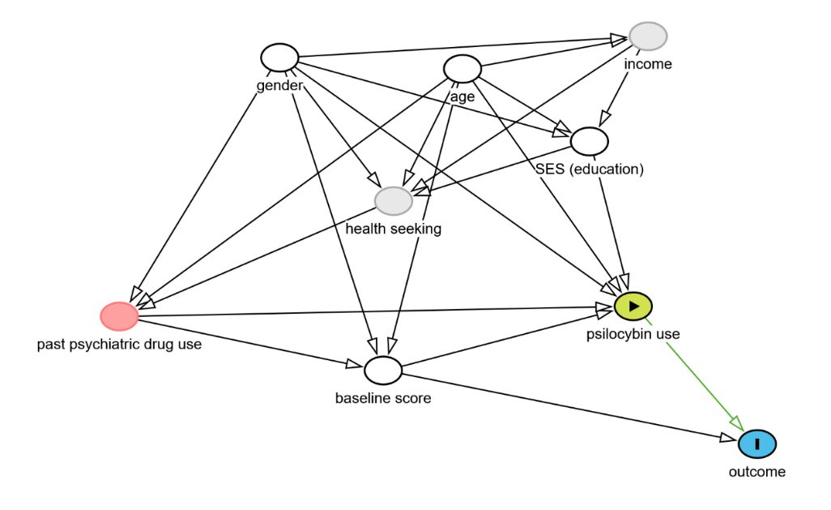
Figure 1. Directed Acyclic Graph showing the assumed relationship between variables in the cohort study.
The temporal relationship between variables also risks confounding. For example, a few respondents selected their last consumption was “in the past week” while the outcome asks about the past 30 days. However, we worked under the assumption that the exposure preceded the outcome because an early exposure may have occurred for these participants because they reported multiple doses during the last year in all cases. Finally, it is also possible for some participants to first have tried psilocybin before other prescribed psychiatric drug (as this question was asked concurrently). However, we worked under the assumption that past psychiatric use led to psilocybin use based on the structure of the special access program and the broader language used to ask about prescription medication (“ever used”).

Statistical methods
All statistical analyses were performed using R version 4.5.1 (R Core Team, 2025). Data about psilocybin use was described using counts and proportions. Differences between exposed and unexposed groups were inspected using chi-square and t-tests. Given only one participant tried psilocybin during Wave 3 for the first time, we chose to use data from Waves 1 and 2 to estimate the effect of psilocybin use on psychological distress.
Several analytical approaches were tested to ensure robustness and account for both observed and unobserved confounding. First, we fitted a lagged dependent variable (LDV) model in a wide format dataset, adjusting for the K6 score at baseline and time-invariant covariates (i.e., age, gender, and education). These set of covariates provided sufficient adjustment to prevent bias based on observables covariates according to our DAG. LDV is useful when allocation is based on real-world effect rather than randomization and the method of choice above alternatives like change in scores when the outcome at baseline is a competing exposure (Keele & Kelly, 2006; Tennant et al., 2022).
Second, we used an inverse probability of treatment weighting approach, predicting the exposure based on the same set of covariates, essentially creating a pseudo-population in which the exposure is independent of them. Extreme weights (>99th percentile) were trimmed to prevent instability (Austin & Stuart, 2015). Finally, we fit a fixed-effects models in long-form data, therefore adjusting for all time-invariant unobserved confounders through within-person estimates.
For our secondary objective, we analyzed the distribution of K6 psychological distress scores over time by intervention status using the Friedman non-parametric test, followed by a Durbin–Conover test for group-wise comparison (Conover & Iman, 1979). Compared periods, therefore, accounted for repeated measurements within participants. The non-parametric alternative was chosen given the small number of participants who had been treated and reported data for all three waves.

Results

Participants
Among 1,249 participants in the Tips and Recommendations for the Ingestion of Psilocybin study, 540 consented to follow-up and provided valid responses for Wave 2, therefore constituting the original cohort for the broader study. We sampled a subset of 110 respondents who, based on their responses through all waves of the survey, had never used psilocybin, after excluding four participants with inconsistent responses (e.g., selecting “never” use at baseline and “in the past five years” at follow-up) and one participant lacked outcome data. Among our final analytic sample respondents for Waves 1 and 2 (n=110), 47.3% (n=52) provided information for Wave 3 whereas the remaining 52.7% (n=58) were lost to follow-up.

Descriptive data
Among the analytic sample of 110 participants, 82 participants did not try psilocybin in the first year, 40 continued not to use it during follow-up, 1 tried it in the second year, and 41 were lost to follow-up (50.0%). No significant differences across age, K6 scores, or strata of education, gender, and past use of prescription drugs were found between groups that finished the study and those lose to follow-up.
Among the 28 participants who reported trying psilocybin at any dose during the first year, 11 tried it again in subsequent follow-up, while 17 were lost to follow-up (60.7%). Participants from the treatment group who were lost to follow-up had lower K6 mean scores at baseline (14.18 vs. 9.29; p= 0.015) and Wave 2 (9.45 vs. 6.06; p= 0.136) and were more likely to identify as women (82.4% vs 27.3%; p-adj= 0.048) than men compared to those who finished the study.
Participants in the intervention and control groups did not significantly differ from each other. All participants characteristics are presented in Table 1.

Table 1. Sociodemographic characteristics and outcome data across waves 1 and 2 for cohort participants.
Variable | Control  (n=82) | Intervention  (n=28) | p value
Age (mean (SD)) | 36.26 (16.03) | 29.86 (14.71) | 0.065
Education = Less than bachelor (%) | 14 (17.1) | 6 (21.4) | 0.816
Past use of prescription drugs (%) | 49 (59.8) | 15 (60.0) | 1
Gender (%) |  |  | 0.92
Man | 18 (22.0) | 6 (21.4)
Other | 12 (14.6) | 5 (17.9)
Woman | 52 (63.4) | 17 (60.7)
K6 score at baseline (mean (SD)) | 10.21 (6.69) | 11.21 (5.33) | 0.472
K6 score at follow-up (mean (SD)) | 9.38 (6.15) | 7.39 (5.84) | 0.138
SD=Standard deviation; p values derive from chi-square test for categorical variables and t-tests for numeric variables.

The number of doses for year one ranged from 1 to 30, with a median of 4 doses and a mean of 6.2 doses. The distribution was positively skewed (4.8), indicating that a few participants used psilocybin much more frequently than most. These patterns persisted during Wave 3, with a median of 4 doses, a mean of 6.7 doses, and a positively skewed (2.6) distribution.

Main effect
According to the LDV model, the follow-up K6 score increased by 0.61 points (95% CI: 0.47 to 0.75) by each unit of increase in the baseline K6 score, before adjusting for sociodemographic variables. The use of psilocybin reduce the K6 score by -2.60 (95% CI: -4.63 to -0.57; R² = 0.427; R² adjusted = 0.416) in the same model. The LDV estimate did not significantly change after adjusting for sociodemographic variables (Table 2). Inspection of residuals versus fitted values indicated no obvious deviations from homoscedasticity or nonlinearity, suggesting that model assumptions were reasonably met (Supplementary Figure S1).
Only 2 participants had extreme weights before trimming. The IPTW produced balanced groups in terms of age, gender, education, and baseline K6 score (SMD=0.03 in all cases). Propensity score distributions for the treatment and control groups showed adequate overlap, indicating sufficient common support for estimating treatment effects (Supplementary Figure S2). The IPTW model estimated a score reduction of -2.58 (95% CI: -5.07 to -0.08; R² = 0.05; R² adjusted = 0.04) before adjusting for sociodemographic variables and baseline score. Once more, the model did not significantly change after adjustment for sociodemographic variables (Table 2).
Finally, the within-subject score change attributable to treatment between waves was estimated at -3.82 (95% CI: -5.80 to -1.84) by the fixed-effects model (within R² = 0.12).
Table 2. Coefficients for the Lagged Dependent Variable (LDV) and Inverse Probability of Treatment Weighted (IPTW) models.
Variable | LVD model estimates | 95% Conf.  Intervals | IPTW model Estimates | 95% Conf.  Intervals
(Intercept) | 3.69 | 0.16 to 7.23 | 2.77 | -1.73 to 7.27
Treatment | -2.63 | -4.70 to -0.56 | -2.49 | -4.53 to -0.46
Baseline K6 score | 0.60 | 0.45 to 0.76 | 0.57 | 0.39 to 0.76
Age | 0.00 | -0.06 to 0.07 | 0.03 | -0.06 to 0.12
Gender [Other] | 0.73 | -2.35 to 3.80 | 1.51 | -2.05 to 5.07
Gender [Woman] | -1.16 | -3.42 to 1.10 | -1.11 | -4.06 to 1.83
Education [< bachelor] | 0.25 | -2.15 to 2.64 | 1.28 | -1.94 to 4.50
R2 / R2 adjusted |  | 0.441 / 0.409 |  | 0.410 / 0.375

Persistence of effect over time
The all pairs-comparison test did not detect significant differences within-subject across time periods in the control group (n=40). The median value for the score changed from 8 at baseline to 7 in both follow-up years, with a relatively similar distribution. Conversely, the median distress score in the intervention (n=14) group dropped from 13.5 at baseline to 6.0 during the first year of follow-up and 9.0 at the end of the study period. The differences were statistically significant compared to baseline values even after accounting for multiple comparisons. No significant differences were found between the scores from Waves 2 and 3 in the intervention group (Figure 2).
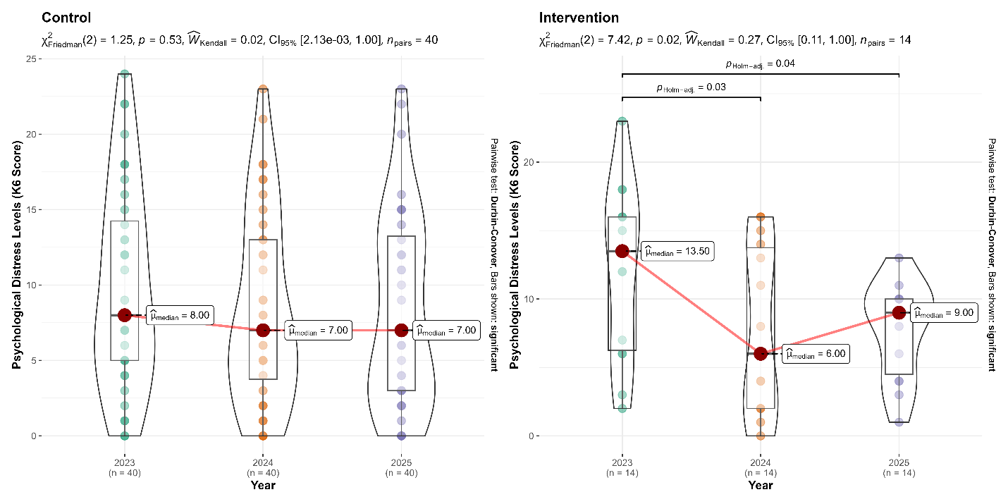

Discussion

Key results
We hypothesized that psilocybin use would lower the level of psychological distress. Our results were confirmed, with a mean score reductions of 2.6 points after adjusting for covariates (n=110). Within-person effects were stronger, with mean score reductions of 3.8 points after treatment. We also hypothesized the effect of psylocibin would be sustained over time, which we confirmed in a small subset of participants (n=14) who provided follow-up data for a second year. The scores for these participants were significantly lower compared to baseline values in years 2 and 3 and did not significantly differ from each other.

Limitations
Our study has several limitations. Online data collection is self-reported and risks introducing recall bias. However, psilocybin use is often cited as one of the most memorable life experiences by past users (Kajonius et al., 2025), which makes recall bias for the exposure—and other variables in the model, which are stable through time—unlikely. Our ability to clearly assert the temporal relationship between some variables was also limited by the data collection instrument. People reporting last psychedelic use could select “past week” whereas the outcome assessed the psychological distress in the past month. However, this only occurred with two participants which reported having taken multiple doses, making it more likely that the exposure preceded the outcome. Moreover, given the direction of the effect, such scenario would bias the estimate towards the null and it is unlikely to affect the overall conclusion. Conversely, past research using self-reported data has found higher benefits than experimental settings (Totomanova et al., 2025). We tried to address this by using validated psychological instruments that had been thoroughly tested in several populations.
Observational studies always risk bias by unmeasured confounding. We tried to mitigate this risk by estimating a fixed-effect model that would account for time-invariant individual characteristics and isolate within-person changes. However, residual confounding from time-varying factors not captured in the model may still influence the observed associations, underscoring the need for cautious interpretation.
Regarding the stability of estimates, we found a relatively higher proportion of participants in the intervention group were lost to follow-up compared to the control group (60.7% vs 50%). When examining the factors associated with missing data in wave 3, we found participants lost to follow-up had lower scores for psychological distress in waves 1 and 2 and were more likely to identify as women, but age and education were not related to attrition as previously reported (Hübner et al., 2021). This pattern suggests that attrition was not completely random and could have influenced our results. However, the overall trends observed in the remaining sample were consistent with earlier waves, providing some reassurance about the robustness of the estimates.

Interpretation
Our findings suggest that psilocybin use is associated with a reduction in psychological distress, both one year after treatment and, for a subset of participants, over a longer follow-up period of two years. The observed within-person reductions were larger than the overall adjusted effects, indicating that individuals experienced meaningful decreases in distress relative to their own baseline. These results align with previous studies suggesting potential therapeutic benefits of psilocybin (Kittur et al., 2025).
Psilocybin is also amenable as a public health intervention because it is cheaper than the current standard of care (Avanceña et al., 2025), it has lower dropout rates due to milder side effects (Hieronymus et al., 2025; Hinkle et al., 2024) and—as attested by our findings—its positive effects seem to persist independent for long periods. While most trials implement psychedelic-assisted therapy, recent analysis also suggests psylocibin might be effective even in the absence of accompanying psychological therapy (Hultgren et al., 2025), i.e., like those reported in naturalistic settings.
Despite these benefits, the access to psilocybin remained constrained not only by legal frameworks but due to social stigma. Past research has shown that some patients, particularly those of older age, will require thoughtful communication that avoids stigma in order to access the benefits of psilocybin (Gillespie & Bering, 2025). Similarly, broader societal efforts are needed to reduce stigma and facilitate equitable access, ensuring that all individuals can benefit from psilocybin treatment.
In Canada, the current Special Access Program does not allow psychedelics as first line therapy, despite users in our sample reporting consumption without previous treatment. Given the accumulating evidence for both the efficacy and safety of psilocybin, there is a compelling rationale for re-evaluating current regulatory frameworks to expand responsible access. Policymakers and healthcare systems should consider pathways that allow psilocybin to be integrated as a treatment option beyond individuals who have not benefited from conventional therapies, while maintaining safeguards to ensure appropriate use. Expanding access in this way has the potential not only to improve individual well-being but also to reduce the broader public health burden associated with persistent psychological distress.

Generalisability
The findings of this study should be interpreted within the context of a voluntary, online Canadian cohort recruited through social media and email campaigns, which may limit representativeness. Participants were self-selected and had access to the internet, meaning the sample likely reflects individuals who are engaged with digital platforms and potentially more open to or informed about psychedelics than the general population. Nevertheless, the lack of significant differences between completers and non-completers, along with the inclusion of participants across a broad age range and educational backgrounds, supports the relevance of these findings to a diverse subset of the Canadian adult population.

Other information

Funding
This study was funded by a private donation from Andrew Beckerman.

References
Abuduxike, G., Aşut, Ö., Vaizoğlu, S. A., & Cali, S. (2019). Health-Seeking Behaviors and its Determinants: A Facility-Based Cross-Sectional Study in the Turkish Republic of Northern Cyprus. International Journal of Health Policy and Management, 1. https://doi.org/10.15171/ijhpm.2019.106
American Psychiatric Association. (2023). Practice Guideline for the Treatment of Patients With Major Depressive Disorder. American Psychiatric Association Publishing. https://www.apa.org/depression-guideline/guideline.pdf
Andrade, F. R. T., Buchborn, T., Thalheimer, G., Meinhardt, M. W., Joca, S., & De Almeida, R. M. M. (2025). Therapeutic Use of Psilocybin in Depression: A Systematic Review of Clinical Evidence. Acta Neuropsychiatrica, 37, e86. https://doi.org/10.1017/neu.2025.10039
Askariyan, K., Joghataei, M. T., Dehghan, S., Nohesara, S., Riahi Pour, L., Mohammadi, M. H., & Ahmadirad, N. (2025). An overview of psilocybin, LSD, MDMA, and ketamine in revitalizing psychedelic-assisted therapy: Insights, limitations and future directions. Progress in Neuro-Psychopharmacology and Biological Psychiatry, 141, 111461. https://doi.org/10.1016/j.pnpbp.2025.111461
Austin, P. C., & Stuart, E. A. (2015). Moving towards best practice when using inverse probability of treatment weighting (IPTW) using the propensity score to estimate causal treatment effects in observational studies. Statistics in Medicine, 34(28), 3661–3679. https://doi.org/10.1002/sim.6607
Avanceña, A. L. V., Vuong, L., Kahn, J. G., & Marseille, E. (2025). Psilocybin-assisted therapy for treatment-resistant depression in the US: A model-based cost-effectiveness analysis. Translational Psychiatry, 15(1), 330. https://doi.org/10.1038/s41398-025-03556-4
Brudner, R. M., Kaczmarek, E., Blainey, M. G., Schulz-Quach, C., Meshkat, S., Doyle, Z., Lipsitz, O., Offman, H., Sethi, R., Weiglein, G., McIntyre, R. S., & Rosenblat, J. D. (2025). Examining mystical experiences as a predictor of psilocybin-assisted psychotherapy for treatment-resistant depression. Journal of Psychopharmacology, 39(9), 950–956. https://doi.org/10.1177/02698811251346697
Bujalski, M., Wieczorek, Ł., & Sierosławski, J. (2021). Risk perception and risk aversion among people who use New Psychoactive Substances. International Journal of Drug Policy, 97, 103326. https://doi.org/10.1016/j.drugpo.2021.103326
Card, K. G., Grewal, A., Closson, K., Martin, G., Baracaldo, L., Allison, S., Kruger, D. J., & Walsh, Z. (2024). Therapeutic Potential of Psilocybin for Treating Psychological Distress among Survivors of Adverse Childhood Experiences: Evidence on Acceptability and Potential Efficacy of Psilocybin Use. Journal of Psychoactive Drugs, 56(5), 616–626. https://doi.org/10.1080/02791072.2023.2268640
Carhart-Harris, R. L., & Goodwin, G. M. (2017). The Therapeutic Potential of Psychedelic Drugs: Past, Present, and Future. Neuropsychopharmacology, 42(11), 2105–2113. https://doi.org/10.1038/npp.2017.84
Cheon, Y., Park, J., Jeong, B. Y., Park, E. Y., Oh, J.-K., Yun, E. H., & Lim, M. K. (2020). Factors associated with psychological stress and distress among Korean adults: The results from Korea National Health and Nutrition Examination Survey. Scientific Reports, 10(1), 15134. https://doi.org/10.1038/s41598-020-71789-y
Conover, W., & Iman, R. (1979). Multiple-comparisons procedures. Informal report (No. LA-7677-MS, 6057803; p. LA-7677-MS, 6057803). https://doi.org/10.2172/6057803
Crichton, P., Carel, H., & Kidd, I. J. (2017). Epistemic injustice in psychiatry. BJPsych Bulletin, 41(2), 65–70. https://doi.org/10.1192/pb.bp.115.050682
Danborg, P. B., Valdersdorf, M., & Gøtzsche, P. C. (2019). Long-term harms from previous use of selective serotonin reuptake inhibitors: A systematic review. International Journal of Risk & Safety in Medicine, 30(2), 59–71. https://doi.org/10.3233/JRS-180046
De Haan, S. (2020). Enactive Psychiatry (1st edn). Cambridge University Press. https://doi.org/10.1017/9781108685214
De Las Cuevas, C., Peñate, W., & Sanz, E. J. (2014). Risk factors for non-adherence to antidepressant treatment in patients with mood disorders. European Journal of Clinical Pharmacology, 70(1), 89–98. https://doi.org/10.1007/s00228-013-1582-9
Doherty, D. T., & Kartalova‐O’Doherty, Y. (2010). Gender and self‐reported mental health problems: Predictors of help seeking from a general practitioner. British Journal of Health Psychology, 15(1), 213–228. https://doi.org/10.1348/135910709X457423
Erritzoe, D., Barba, T., Greenway, K. T., Murphy, R., Martell, J., Giribaldi, B., Timmermann, C., Murphy-Beiner, A., Jones, M. B., Nutt, D., Weiss, B., & Carhart-Harris, R. (2024). Effect of psilocybin versus escitalopram on depression symptom severity in patients with moderate-to-severe major depressive disorder: Observational 6-month follow-up of a phase 2, double-blind, randomised, controlled trial. eClinicalMedicine, 76, 102799. https://doi.org/10.1016/j.eclinm.2024.102799
Fan, Y., Fan, A., Yang, Z., & Fan, D. (2025). Global burden of mental disorders in 204 countries and territories, 1990–2021: Results from the global burden of disease study 2021. BMC Psychiatry, 25(1), 486. https://doi.org/10.1186/s12888-025-06932-y
García, E., & Barandiaran, X. E. (2025). Varieties of normativity and mental health: An enactive approach. Synthese, 205(2), 53. https://doi.org/10.1007/s11229-024-04854-y
Gillespie, C. M., & Bering, J. M. (2025). Avoiding Stigma and Sensationalism in Therapeutic Psilocybin Communications: Considerations for Reaching Older Patients. The American Journal of Geriatric Psychiatry, 33(12), 1251–1259. https://doi.org/10.1016/j.jagp.2025.07.003
Graziosi, M., Singh, M., Nayak, S. M., & Yaden, D. B. (2023). Acute Subjective Effects of Psychedelics within and Beyond WEIRD Contexts. Journal of Psychoactive Drugs, 55(5), 558–569. https://doi.org/10.1080/02791072.2023.2255274
Griffiths, R. R., Richards, W. A., McCann, U., & Jesse, R. (2006). Psilocybin can occasion mystical-type experiences having substantial and sustained personal meaning and spiritual significance. Psychopharmacology, 187(3), 268–283. https://doi.org/10.1007/s00213-006-0457-5
Hernández-López, M., Cepeda-Benito, A., Díaz-Pavón, P., & Rodríguez-Valverde, M. (2021). Psychological inflexibility and mental health symptoms during the COVID-19 lockdown in Spain: A longitudinal study. Journal of Contextual Behavioral Science, 19, 42–49. https://doi.org/10.1016/j.jcbs.2020.12.002
Hieronymus, F., López, E., Werin Sjögren, H., & Lundberg, J. (2025). Control Group Outcomes in Trials of Psilocybin, SSRIs, or Esketamine for Depression: A Meta-Analysis. JAMA Network Open, 8(7), e2524119. https://doi.org/10.1001/jamanetworkopen.2025.24119
Hinkle, J. T., Graziosi, M., Nayak, S. M., & Yaden, D. B. (2024). Adverse Events in Studies of Classic Psychedelics: A Systematic Review and Meta-Analysis. JAMA Psychiatry, 81(12), 1225. https://doi.org/10.1001/jamapsychiatry.2024.2546
Hsu, T., Adamowicz, J. L., & Thomas, E. B. K. (2023). The effect of acceptance and commitment therapy on the psychological flexibility and inflexibility of undergraduate students: A systematic review and three-level meta-analysis. Journal of Contextual Behavioral Science, 30, 169–180. https://doi.org/10.1016/j.jcbs.2023.10.006
Hübner, S., Haijen, E., Kaelen, M., Carhart-Harris, R. L., & Kettner, H. (2021). Turn on, Tune in, and Drop out: Predictors of Attrition in a Prospective Observational Cohort Study on Psychedelic Use. Journal of Medical Internet Research, 23(7), e25973. https://doi.org/10.2196/25973
Hultgren, J., Hafsteinsson, M. H., & Brulin, J. G. (2025). A dose of therapy with psilocybin—A meta-analysis of the relationship between the amount of therapy hours and treatment outcomes in psychedelic-assisted therapy. General Hospital Psychiatry, 96, 234–243. https://doi.org/10.1016/j.genhosppsych.2025.07.020
Hutto, D. D., & Myin, E. (2013). Radicalizing enactivism: Basic minds without content. MIT Press.
IsHak, W. W., Garcia, P., Pearl, R., Dang, J., William, C., Totlani, J., & Danovitch, I. (2023). The Impact of Psilocybin on Patients Experiencing Psychiatric Symptoms: A Systematic Review of Randomized Clinical Trials. Innovations in Clinical Neuroscience, 20(4–6), 39–48.
Jacob, K. S. (2015). Recovery Model of Mental Illness: A Complementary Approach to Psychiatric Care. Indian Journal of Psychological Medicine, 37(2), 117–119. https://doi.org/10.4103/0253-7176.155605
Kajonius, P. J., Sjöström, D., & Claesdotter-Knutsson, E. (2025). Big Five personality and the psychedelic experience: An initial report. Journal of Psychedelic Studies. https://doi.org/10.1556/2054.2025.00414
Kashdan, T. B., Disabato, D. J., Goodman, F. R., Doorley, J. D., & McKnight, P. E. (2020). Understanding psychological flexibility: A multimethod exploration of pursuing valued goals despite the presence of distress. Psychological Assessment, 32(9), 829–850. https://doi.org/10.1037/pas0000834
Kashdan, T. B., & Rottenberg, J. (2010). Psychological flexibility as a fundamental aspect of health. Clinical Psychology Review, 30(7), 865–878. https://doi.org/10.1016/j.cpr.2010.03.001
Keele, L., & Kelly, N. J. (2006). Dynamic Models for Dynamic Theories: The Ins and Outs of Lagged Dependent Variables. Political Analysis, 14(2), 186–205.
Kessler, R. C., Andrews, G., Colpe, L. J., Hiripi, E., Mroczek, D. K., Normand, S.-L. T., Walters, E. E., & Zaslavsky, A. M. (2002). Short screening scales to monitor population prevalences and trends in non-specific psychological distress. Psychological Medicine, 32(6), 959–976. https://doi.org/10.1017/S0033291702006074
Kessler, R. C., Green, J. G., Gruber, M. J., Sampson, N. A., Bromet, E., Cuitan, M., Furukawa, T. A., Gureje, O., Hinkov, H., Hu, C., Lara, C., Lee, S., Mneimneh, Z., Myer, L., Oakley‐Browne, M., Posada‐Villa, J., Sagar, R., Viana, M. C., & Zaslavsky, A. M. (2010). Screening for serious mental illness in the general population with the K6 screening scale: Results from the WHO World Mental Health (WMH) survey initiative. International Journal of Methods in Psychiatric Research, 19(S1), 4–22. https://doi.org/10.1002/mpr.310
Kittur, M. E., Burgos M., L. A., Jones, B. D. M., Blumberger, D. M., Mulsant, B. H., Rosenblat, J. D., & Husain, M. I. (2025). Mapping psilocybin therapy: A systematic review of therapeutic frameworks, adaptations, and standardization across contemporary clinical trials. Journal of Affective Disorders, 391, 119952. https://doi.org/10.1016/j.jad.2025.119952
Ko, K., Knight, G., Rucker, J. J., & Cleare, A. J. (2022). Psychedelics, Mystical Experience, and Therapeutic Efficacy: A Systematic Review. Frontiers in Psychiatry, 13, 917199. https://doi.org/10.3389/fpsyt.2022.917199
Kovacs, M., Joormann, J., & Gotlib, I. H. (2008). Emotion (Dys)regulation and Links to Depressive Disorders. Child Development Perspectives, 2(3), 149–155. https://doi.org/10.1111/j.1750-8606.2008.00057.x
Lerner, M., & Lyvers, M. (2006). Values and Beliefs of Psychedelic Drug Users: A Cross-Cultural Study. Journal of Psychoactive Drugs, 38(2), 143–147. https://doi.org/10.1080/02791072.2006.10399838
Li, L.-J., Mo, Y., Shi, Z.-M., Huang, X.-B., Ning, Y.-P., Wu, H.-W., Yang, X.-H., & Zheng, W. (2024). Psilocybin for major depressive disorder: A systematic review of randomized controlled studies. Frontiers in Psychiatry, 15, 1416420. https://doi.org/10.3389/fpsyt.2024.1416420
Moncrieff, J. (2018a). Against the stream: Antidepressants are not antidepressants – an alternative approach to drug action and implications for the use of antidepressants. BJPsych Bulletin, 42(1), 42–44. https://doi.org/10.1192/bjb.2017.11
Moncrieff, J. (2018b). What does the latest meta-analysis really tell us about antidepressants? Epidemiology and Psychiatric Sciences, 27(5), 430–432. https://doi.org/10.1017/S2045796018000240
Moncrieff, J., Cooper, R. E., Stockmann, T., Amendola, S., Hengartner, M. P., & Horowitz, M. A. (2023). The serotonin theory of depression: A systematic umbrella review of the evidence. Molecular Psychiatry, 28(8), 3243–3256. https://doi.org/10.1038/s41380-022-01661-0
Nayak, S. M., Jackson, H., Sepeda, N. D., Mathai, D. S., So, S., Yaffe, A., Zaki, H., Brasher, T. J., Lowe, M. X., Jolly, D. R. P., Barrett, F. S., Griffiths, R. R., Strickland, J. C., Johnson, M. W., Jackson, H., & Garcia-Romeu, A. (2023). Naturalistic psilocybin use is associated with persisting improvements in mental health and wellbeing: Results from a prospective, longitudinal survey. Frontiers in Psychiatry, 14, 1199642. https://doi.org/10.3389/fpsyt.2023.1199642
Paiva, T., Silva, A. N. D., Neto, D. D., Karekla, M., Kassianos, A. P., & Gloster, A. (2024). The Effect of Psychological Flexibility on Well-Being during the COVID-19 Pandemic: The Multiple Mediation Role of Mindfulness and Coping. Behavioral Sciences, 14(7), 545. https://doi.org/10.3390/bs14070545
Pirani, Y., Delgado-Ron, J. A., Marinho, P., Gupta, A., Gray, E., Watt, S., & Salway, T. (2023). Frequency of self-reported persistent post-treatment genital hypesthesia among past antidepressant users: A cross-sectional survey of sexual and gender minority youth in Canada and the US. https://doi.org/10.31219/osf.io/qha9n
R Core Team. (2025). R: A Language and Environment for Statistical Computing. R Foundation for Statistical Computing. https://www.R-project.org/
Rajwani, K., Jacobs, E., Bruce, L., Hokanson, J., Almonte, M. T., Feroz, F., Waldman, E., Cheung, K., Levy, N., Savulescu, J., Singh, I., Yaden, D. B., & Earp, B. D. (2025). Clinical psychedelic research in adolescents: A scoping review and overview of ethical considerations. The Lancet Child & Adolescent Health, 9(10), 744–752. https://doi.org/10.1016/S2352-4642(25)00208-1
Richard, J., Garcia-Romeu, A., & Henningfield, J. E. (2025). Expanded access to psychedelic treatments: Comparing American and Canadian policies. General Psychiatry, 38(1), e101894. https://doi.org/10.1136/gpsych-2024-101894
Ross, M. L., Iyer, R., Williams, M. L., Boughey, M., O’Callaghan, C., Hiscock, R., & Dwyer, J. (2025). Psilocybin-assisted psychotherapy for depression and anxiety associated with life threatening illness: A phase 2b randomized controlled trial. General Hospital Psychiatry, 96, 322–331. https://doi.org/10.1016/j.genhosppsych.2025.08.001
Santomauro, D. F., Mantilla Herrera, A. M., Shadid, J., Zheng, P., Ashbaugh, C., Pigott, D. M., Abbafati, C., Adolph, C., Amlag, J. O., Aravkin, A. Y., Bang-Jensen, B. L., Bertolacci, G. J., Bloom, S. S., Castellano, R., Castro, E., Chakrabarti, S., Chattopadhyay, J., Cogen, R. M., Collins, J. K., … Ferrari, A. J. (2021). Global prevalence and burden of depressive and anxiety disorders in 204 countries and territories in 2020 due to the COVID-19 pandemic. The Lancet, 398(10312), 1700–1712. https://doi.org/10.1016/S0140-6736(21)02143-7
Seighali, N., Abdollahi, A., Shafiee, A., Amini, M. J., Teymouri Athar, M. M., Safari, O., Faghfouri, P., Eskandari, A., Rostaii, O., Salehi, A. H., Soltani, H., Hosseini, M., Abhari, F. S., Maghsoudi, M. R., Jahanbakhshi, B., & Bakhtiyari, M. (2024). The global prevalence of depression, anxiety, and sleep disorder among patients coping with Post COVID-19 syndrome (long COVID): A systematic review and meta-analysis. BMC Psychiatry, 24(1), 105. https://doi.org/10.1186/s12888-023-05481-6
Smausz, R., Neill, J., & Gigg, J. (2022). Neural mechanisms underlying psilocybin’s therapeutic potential – the need for preclinical in vivo electrophysiology. Journal of Psychopharmacology, 36(7), 781–793. https://doi.org/10.1177/02698811221092508
Swieczkowski, D., Kwaśny, A., Ciurkowska, P., Pruc, M., Szarpak, L., & Cubała, W. J. (2025). Unequal representation? A cross-sectional analysis of age, sex, race, and ethnicity in clinical trials of classic psychedelics. Journal of Psychopharmacology, 39(9), 1014–1022. https://doi.org/10.1177/02698811251353250
Tebeka, S., Coste, J., Makovski, T. T., Alleaume, C., Delpierre, C., Gallay, A., Pignon, B., Gouraud, C., Ouazana Vedrines, C., Pitron, V., Robineau, O., Steichen, O., & Lemogne, C. (2024). Dissecting the association between long COVID and depressive symptoms in a nationally representative population from France. Journal of Psychosomatic Research, 187, 111961. https://doi.org/10.1016/j.jpsychores.2024.111961
Tennant, P. W. G., Arnold, K. F., Ellison, G. T. H., & Gilthorpe, M. S. (2022). Analyses of ‘change scores’ do not estimate causal effects in observational data. International Journal of Epidemiology, 51(5), 1604–1615. https://doi.org/10.1093/ije/dyab050
Totomanova, I., Haijen, E. C. H. M., Hurks, P. P. M., Ramaekers, J. G., & Kuypers, K. P. C. (2025). Between enhancement and risk: A critical review of psychedelic microdosing. Current Opinion in Psychology, 66, 102129. https://doi.org/10.1016/j.copsyc.2025.102129
Watts, R., Day, C., Krzanowski, J., Nutt, D., & Carhart-Harris, R. (2017). Patients’ Accounts of Increased “Connectedness” and “Acceptance” After Psilocybin for Treatment-Resistant Depression. Journal of Humanistic Psychology, 57(5), 520–564. https://doi.org/10.1177/0022167817709585
Weiss, D., Lowenstein, C., Sund, E. R., Vethe, D., & Krokstad, S. (2025). Diverging mental health trends in the postpandemic era: Results from the HUNT Study, Norway. Journal of Epidemiology and Community Health, 79(3), 165. https://doi.org/10.1136/jech-2024-222626
Wong, S., Meckling, G., Fabiano, N., Lee, S., Jones, B. D. M., Shorr, R., Dargel, A., Davis, A. K., Fiedorowicz, J. G., Solmi, M., Rosenblat, J. D., Mulsant, B. H., Blumberger, D. M., & Husain, M. I. (2025). Effect of psilocybin therapy on suicidal ideation, attempts, and deaths in people with psychiatric diagnoses: A systematic review and meta-analysis. Therapeutic Advances in Psychopharmacology, 15, 20451253251372449. https://doi.org/10.1177/20451253251372449
World Health Organization. (2025). World mental health today: Latest data. World Health Organization.
World Health Organization (with World Health Organization). (2023). Mental Health Gap Action Programme (mhGAP) guideline for mental, neurological and substance use disorders. World Health Organization.
Yao, X., Xu, X., Chan, K. L., Chen, S., Assink, M., & Gao, S. (2023). Associations between psychological inflexibility and mental health problems during the COVID-19 pandemic: A three-level meta-analytic review. Journal of Affective Disorders, 320, 148–160. https://doi.org/10.1016/j.jad.2022.09.116

Appendix
Figure S1. Residual plots for the LDV and IPTW models.
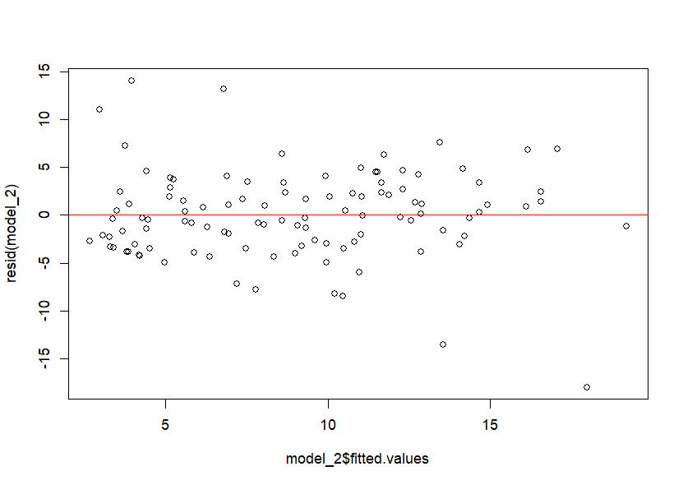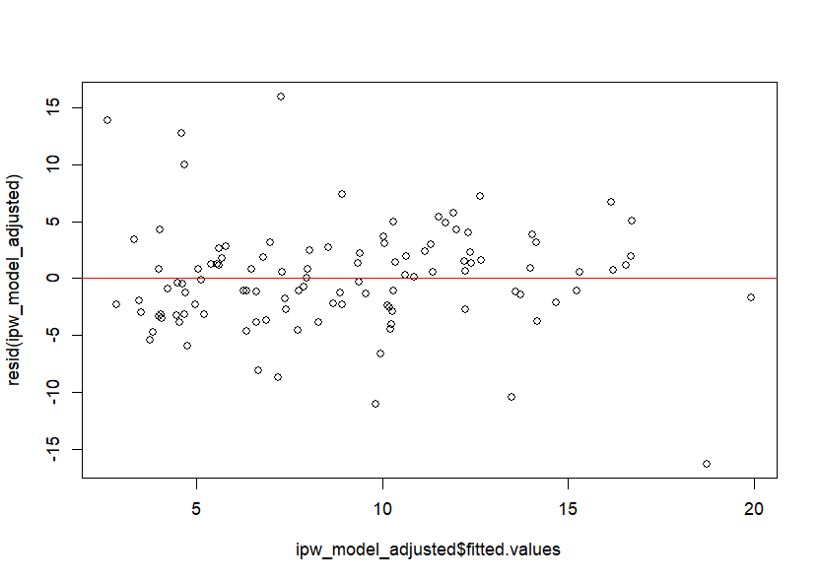
Figure S2. Propensity scores by treatment group.
